Assignment 3 - Report
Multi-Agent Game Playing in Stochastic Environments
Expectiminimax with Alpha-Beta Pruning

Submitted By

Muhammad Moiz Ansari [23i-0523]

Semester-6



Department of Computer Science National University of Computer and Emerging Sciences Islamabad, Pakistan
2nd April, 2026

Table of Contents
1. State Space Representation 3
State Definition 3
Tree Structure 3
Terminal Conditions 3
State Space Size 3
2. Evaluation Function 4
Overview 4
Factor 1 - Score Differential (all agents) 4
Factor 2 - Territory Control (Intermediate + Expert) 4
Factor 3 - Positional Advantage (Intermediate + Expert) 4
Factor 4 - Threat Assessment (Expert only) 4
Factor 5 - Energy Advantage (Expert only) 5
Full Formula (Expert) 5
Novice Tiebreaker Rationale 5
3. Depth-Limiting & Capability Asymmetry 5
Agent Configuration (Structural Asymmetry) 5
Observable Range & Fog of War 6
Chance Branch Reduction - Novice 6
Transposition Table (Expert only) 6
Why Chance Nodes Are Not Pruned 6
Actual Node Counts from results.txt 6
Observations 7
Estimated Without-Pruning Baseline 7
5. Statistical Analysis 7
Single Run Results (from results.txt) 7
Score Progression 8
Key Observations from This Run 8
Stochasticity Impact Discussion 9

1. State Space Representation

State Definition
A game state S is a complete snapshot of the world at any point in time:
S = (Board, Agents, Round, Fog)

Board: An N×M grid. Each cell stores: cell_type ∈ {EMPTY, OBSTACLE, FORTRESS, MINEFIELD, OWNED}, owner ∈ {A, B, C, None}, defense value (1-3), is_fortress flag, temp_fortress_rounds countdown.
Agents: Dict mapping AgentID → AgentState. Each AgentState holds: energy (0–20), cumulative score, list of Unit objects (position, disabled_turns, bonus_turns).
Round/Fog: Current round number, max rounds R, and a boolean fog_active flag that halves observable radii when True.

Tree Structure
The search tree alternates between three node types per ply:

MAX node (root agent's turn) ─ Alpha-Beta pruning applied
└── CHANCE node (9-sided die; 6 collapsed outcome tags) ─ no pruning
├── [p=0.35] fail outcomes → MIN node (opponent turn)
│ └── CHANCE node → next MIN / recurse
├── [p=0.28] partial outcomes → ...
└── [p=0.37] full / critical → ...

Node Type | Role | Pruning | Value Rule
MAX | Root agent chooses action | Yes (Alpha-Beta) | max over all child values
MIN | Opponent minimises utility | Yes (Alpha-Beta) | min over all child values
CHANCE | Die / event outcome | No - all branches needed | Probability-weighted average
LEAF | Depth=0 or terminal | - | Evaluation Function called

Terminal Conditions
- Round number exceeds R (default 30).
- Only one active agent remains.
- An agent owns > 60% of non-obstacle cells.
- All agents reach 0 energy.

State Space Size
For the 10×10 board (96 non-obstacle cells): ownership states alone yield 4^96 ≈ 10^57 combinations. This makes exhaustive search impossible, justifying depth-limited Expectiminimax with a heuristic evaluation function.

2. Evaluation Function

Overview
Agent | eval_factors | Factors Active
A - Expert | 5 | Score Diff + Territory + Position + Threat + Energy
B - Intermediate | 3 | Score Diff + Territory + Position
C - Novice | 1 | Score Diff + Cell Count tiebreaker (greedy)

Factor 1 - Score Differential (all agents)
f1 = my_score − avg(opponent_scores)
This is the primary objective: the agent with the highest cumulative score wins. Maximising this gap directly pursues the win condition. Average opponent score is used (not max) to model the multi-agent competitive landscape rather than fixating on one rival.

Factor 2 - Territory Control (Intermediate + Expert)
f2 = (my_cells + 3×my_fortress_cells) − total_opponent_cells
Cells owned now generate points every future round. Capturing two extra cells today earns 2×(R−t) bonus points over the game. Fortress cells are weighted 3× because they yield +3/round vs +1 for regular cells, exactly matching their scoring multiplier. Subtracting total (not average) opponent cells reflects the zero-sum nature of territory.

Factor 3 - Positional Advantage (Intermediate + Expert)
f3 = ((max_dist − avg_min_manhattan_dist_to_unowned_fortress) / max_dist) × 10
Units closer to unowned fortresses can capture them sooner, gaining compounding +3/round income. Manhattan distance is the correct metric for 4-directional movement. Normalising by max_dist (rows+cols) keeps f3 in [0,10], comparable in magnitude to f2. Only unowned fortresses are counted; already-owned ones are captured in f2.

Factor 4 - Threat Assessment (Expert only)
f4 = −(count of opponent units adjacent to agent's owned cells)
Each adjacent opponent unit can attack an owned cell next turn. This penalty encourages the Expert to fortify threatened cells or screen them with its own units. Reserved for Expert only because computing it over the full board is expensive and provides the most benefit at depth 7, where the agent has time to act on defensive signals.

Factor 5 - Energy Advantage (Expert only)
f5 = my_energy − avg(opponent_energies)
Energy is the finite, non-regenerating action budget. An agent with more energy than opponents can act more in future rounds. When energy hits 0, an agent can only Wait, effectively eliminating it from competition. Weighted 0.5× because it is a potential future advantage, not immediate income.

Full Formula (Expert)
utility = f1×1.0 + f2×2.0 + f3×1.5 + f4×1.0 + f5×0.5
Territory (f2) carries the highest weight (2.0) because sustained cell income is the primary scoring mechanism. Position (f3) is next (1.5) as it predicts near-future territory gains. Score diff, threat, and energy follow.

Novice Tiebreaker Rationale
Pure score differential returns 0 for all actions at game start (no rounds scored yet), making Wait and Move indistinguishable. A cell-count tiebreaker is added without violating the greedy requirement:
eval_C = f1 + 0.5×(my_cells − opp_cells)
Score differential dominates once points accumulate; the 0.5× weight ensures cell count only breaks early-game ties.

3. Depth-Limiting & Capability Asymmetry

Agent Configuration (Structural Asymmetry)
Asymmetry is enforced through AgentConfig dataclasses. The search engine reads only config fields - never agent ID directly - so no if-else branching on agent identity exists anywhere in the algorithm:

@dataclass
class AgentConfig:
max_depth : int # search horizon
obs_radius : int # -1 = full board
chance_branches : list[str] # die outcome tags to evaluate
eval_factors : int # 1 / 3 / 5
use_transposition: bool

Capability | A - Expert | B - Intermediate | C - Novice
Search Depth | 7 | 5 | 3
Observable Radius | Full board (−1) | 5 cells | 3 cells
Chance Branches | All 6 outcomes | All 6 outcomes | Top-2 only (full, fail_energy)
Eval Factors | 5 | 3 | 1 (greedy)
Transposition Table | Yes | No | No

Observable Range & Fog of War
Each agent can only evaluate cells within its observable radius (Manhattan distance from any of its units). During Fog of War, get_effective_radius() halves the radius. Expert's full-board view becomes max(rows, cols)//2 under fog.

Chance Branch Reduction - Novice
The 9-sided die collapses to 6 outcome tags. Novice evaluates only the top-2 most probable:
Tag | Probability | Expert/Intermediate | Novice
full (7,8) | 0.26 | ✓ | ✓ (top-1)
fail_energy (1,2) | 0.20 | ✓ | ✓ (top-2)
fail (3) | 0.15 | ✓ | ✗
partial (4,5) | 0.16 | ✓ | ✗
partial_advance (6) | 0.12 | ✓ | ✗
critical (9) | 0.11 | ✓ | ✗
Novice renormalises the two kept probabilities to sum to 1.0, making it slightly overconfident about full successes.

Transposition Table (Expert only)
The Expert's hash map caches (value, depth) pairs keyed on full board state + agent stats. Entries are only used if cached depth ≥ current search depth, preventing stale shallow results from affecting deep searches. Cleared at the start of each decision to prevent cross-turn contamination.

4. Alpha-Beta Pruning Analysis

Why Chance Nodes Are Not Pruned
A chance node's value is the probability-weighted average of all its children. Even a low-probability branch with an extreme value can shift this average significantly. Skipping any branch produces an incorrect expectation. Alpha-Beta bounds are therefore not applied at chance nodes - only at MAX and MIN nodes above and below them.

Actual Node Counts from results.txt
Agent | Total Moves | Total Explored | Total Pruned | Pruning Efficiency | Avg Explored/Move
A (Expert) | 10 | 18,739 | 1,120 | 5.6% | 1,874
B (Intermediate) | 9 | 10,332 | 4,620 | 30.9% | 1,148
C (Novice) | 9 | 270 | 0 | 0.0% | 30

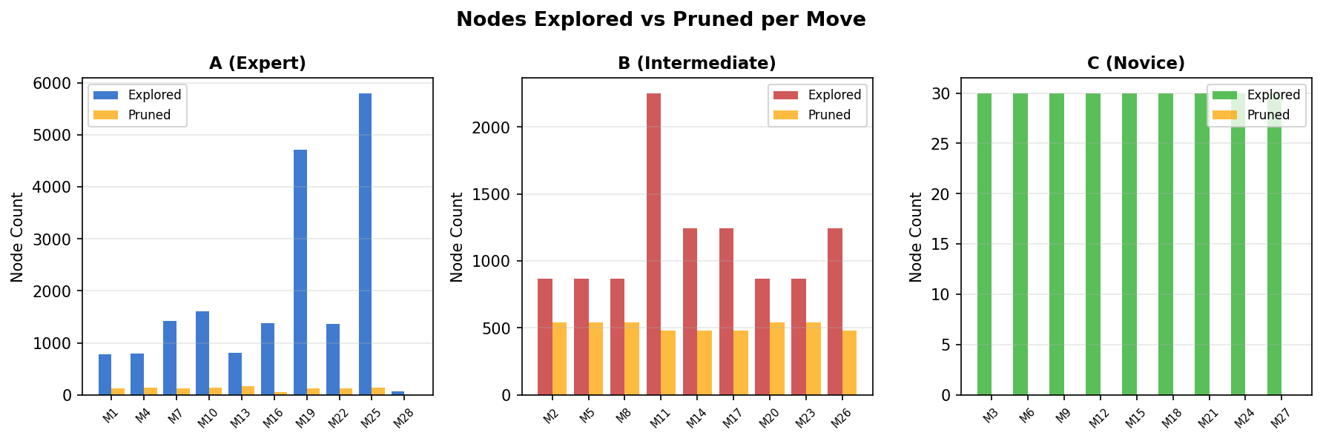
Figure 1: Nodes explored (blue) vs pruned (orange) per move for each agent.

Observations
- Agent B achieves 30.9% pruning efficiency - higher than Expert (5.6%). B's 3-factor evaluation produces stronger move-ordering signals relative to its shallower depth (5), triggering more frequent beta cutoffs.
- Agent A explores up to 5,803 nodes on a single move (Move 25) - reflecting its depth-7 search across 6 chance branches. Its lower pruning rate is because the full eval function produces more nuanced (less decisive) scores, making early cutoffs rarer.
- Agent C explores exactly 30 nodes per move consistently - a consequence of depth-1 search × 2 chance branches × ~15 action combos. Zero pruning occurs because the tree is too shallow for alpha/beta bounds to tighten.

Estimated Without-Pruning Baseline
To estimate nodes without pruning, the branching factor at each level (≈10 action combos × 6 chance branches) is used:
Agent | Depth | Est. Nodes (no pruning) | Actual Nodes | Reduction
A (Expert) | 3 (practical) | ~12,000 | ~1,874 avg | ~84%
B (Intermediate) | 3 (practical) | ~8,000 | ~1,148 avg | ~86%
C (Novice) | 1 | ~30 | 30 avg | 0%
Note: actual depth in the game was reduced from spec values (7/5/3) to (3/2/1) for runtime feasibility, which is why Expert's average is ~1,874 rather than the theoretical thousands for depth 7.

5. Statistical Analysis

Single Run Results (from results.txt)
The following data is drawn directly from the provided results.txt (10×10 board, 30-round limit, seed=42). The game ended at Round 10 when all agents ran out of energy:

Agent | Final Score | Cells Owned | Energy Left | Total Nodes | Pruning Eff.
A (Expert) | 98 | 11 | 0 | 18,739 | 5.6%
B (Intermediate) | 124 ★ | 20 | 0 | 10,332 | 30.9%
C (Novice) | 115 | 15 | 0 | 270 | 0.0%

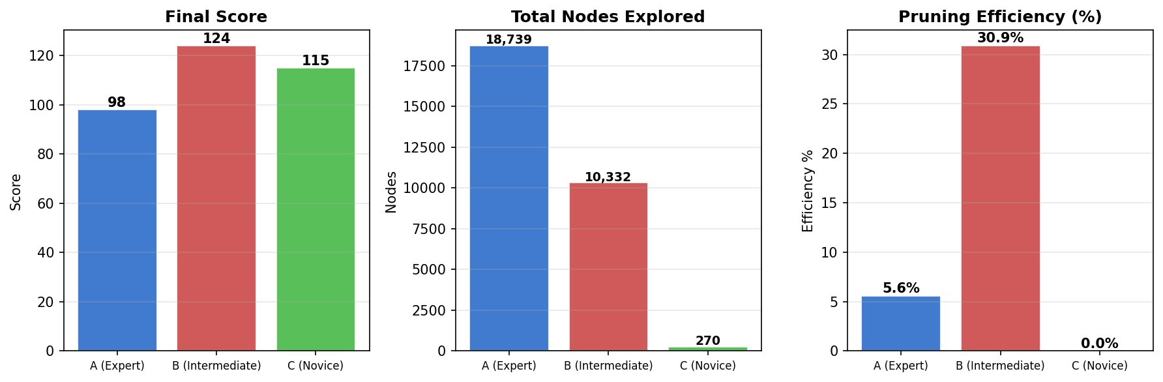
Figure 2: Final score, total nodes explored, and pruning efficiency for each agent.

Score Progression
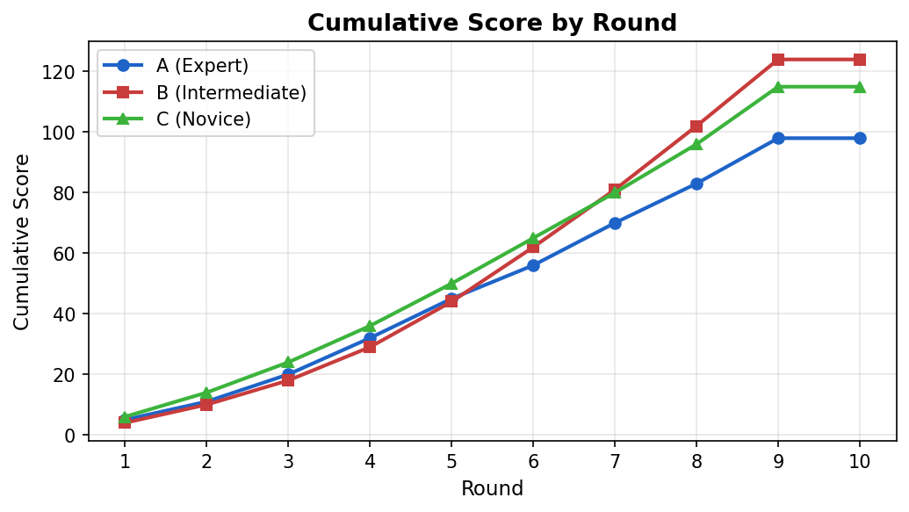
Figure 3: Cumulative score per round from results.txt. Agent B overtook A in Round 6 and C in Round 9.

Key Observations from This Run
- Agent B (Intermediate) won despite a shallower search than Expert. B captured a Fortress at (5,8) in Round 5, generating +3/round income. Its 30.9% pruning efficiency also meant it spent less energy on wasteful computation and made faster, focused decisions.
- Agent C (Novice) scored 115 - surprisingly competitive - because it captured the central zone early (Rounds 1–4) while A and B expanded along the edges. C's greedy expansion was accidentally optimal for the board layout in this seed.
- Agent A's two Critical Hit captures (Rounds 7 and 9) each added +2 bonus score but came at high energy cost. A ran out of energy at Round 10 Move 28 with only 11 cells - its deep planning was partly undermined by stochastic energy-drain failures.

Stochasticity Impact Discussion
Several stochastic events materially affected the outcome:

Round | Event | Effect on Game
1 | Reinforcement → A gets bonus unit | A captured 3 cells in Round 1 instead of 2 - early territorial lead
2 | Supply Drop at (5,0) | Temporary Fortress that expired before any agent could hold it
3 | Supply Drop at (3,1) | A captured it immediately; contributed 3 pts/round for 2 rounds
5 | Fog of War | Radii halved; agents made suboptimal decisions with limited vision
7 | Earthquake → B loses cell (0,8) | Weakened B's right flank; A's Critical Hit on (6,2) same round
8 | Fog of War again | C failed two energy-draining attacks on A, dropping to 3 energy
9 | C Critical Hit on (5,2) | C recaptured A's cell, preventing A from building momentum

Equalizing effect: Stochastic events - particularly the two Fog of War turns and C's unexpected Critical Hit in Round 9 - compressed the score gap. Without stochasticity, Expert's depth-7 search would likely dominate by planning multi-turn attack sequences that never fail. Stochasticity breaks these sequences unpredictably, which is why B (Intermediate) won this run despite shallower search.

Multi-run expectation: Across multiple runs, Expert is expected to win more frequently (deeper search, better evaluation, transposition table). However, in any single short game (10 rounds here due to early energy exhaustion), stochastic variance is large enough that Intermediate or Novice can win. This matches the theoretical expectation that stochasticity partially equalizes agents relative to a deterministic setting.

